**MODULE 5**

What are the new tags added in HTML5?

New tags added in Html is

<!doctype html>

<article>

<aside>

<audio>

<nav>

<header>

<footer>

<section>

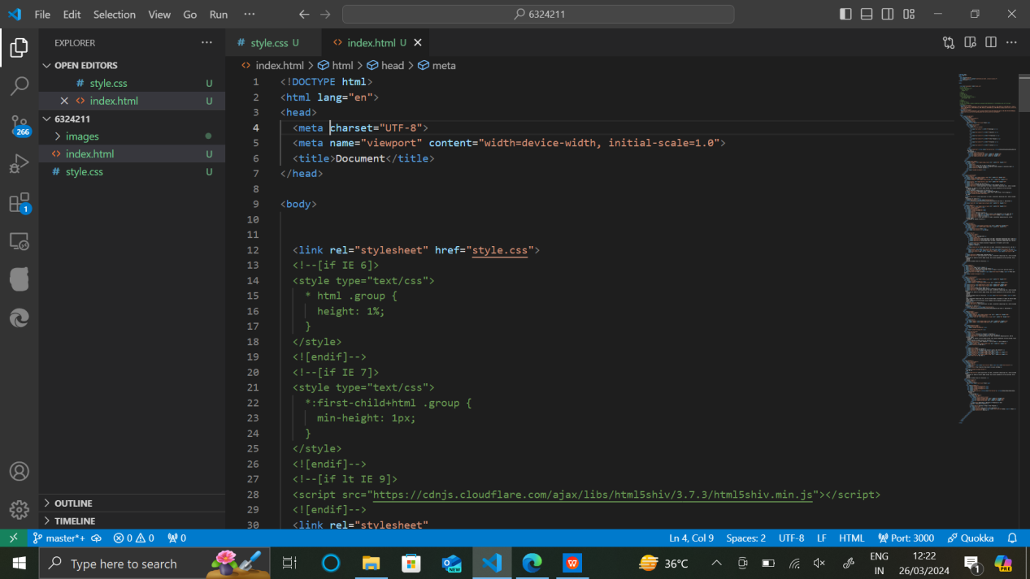

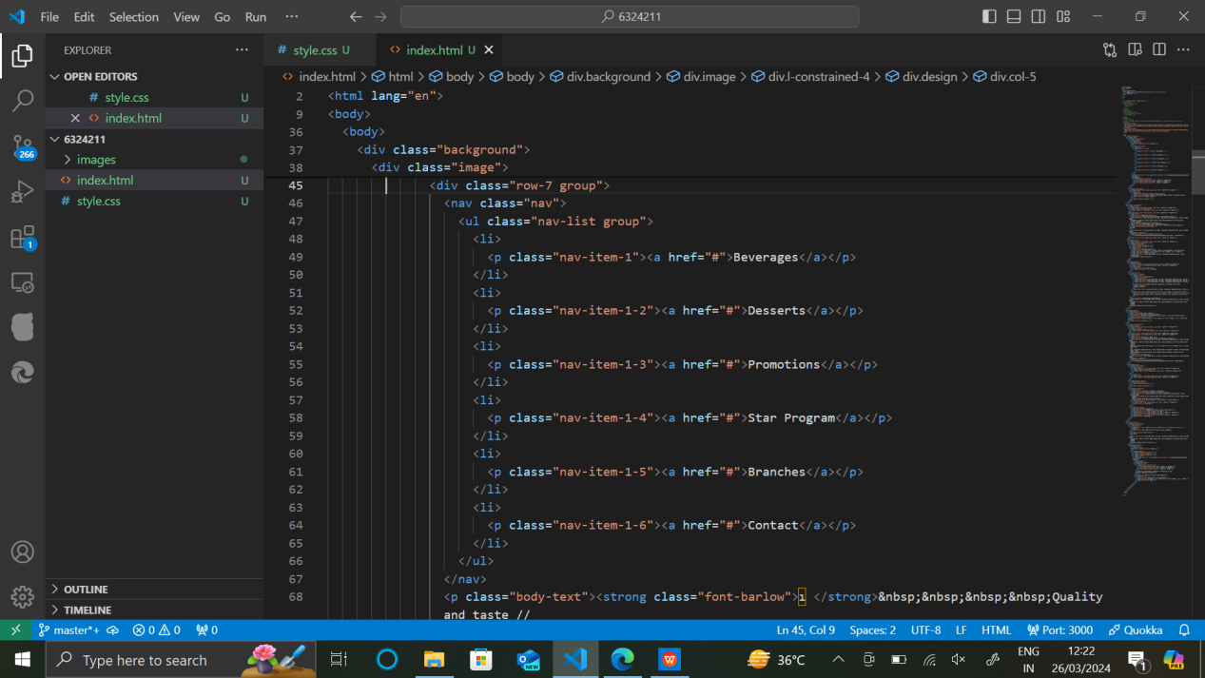

How to embed audio and video in a webpage?

Here are the steps

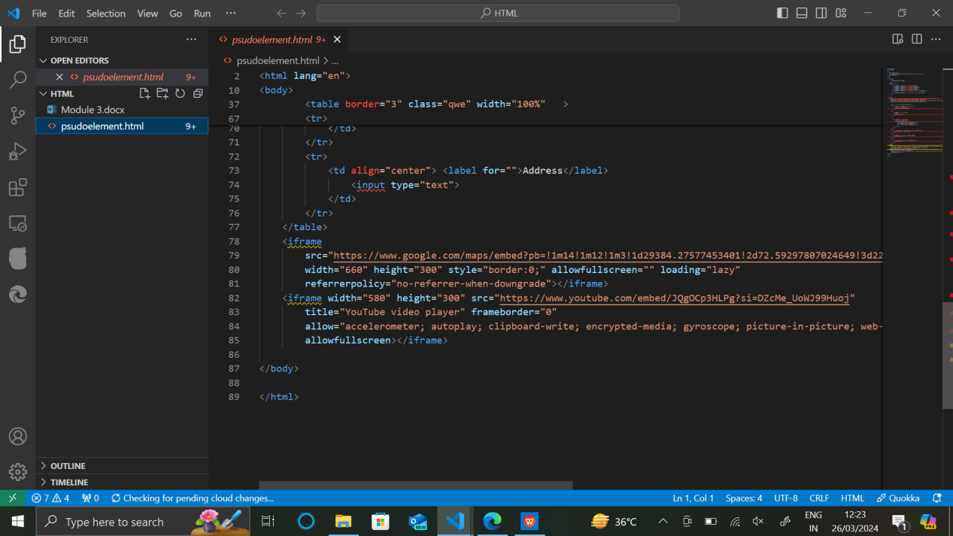

Semantic element in HTML5?

Semantic tags are

<header>

<footer>

<article>

<main>

<summary>

<section>

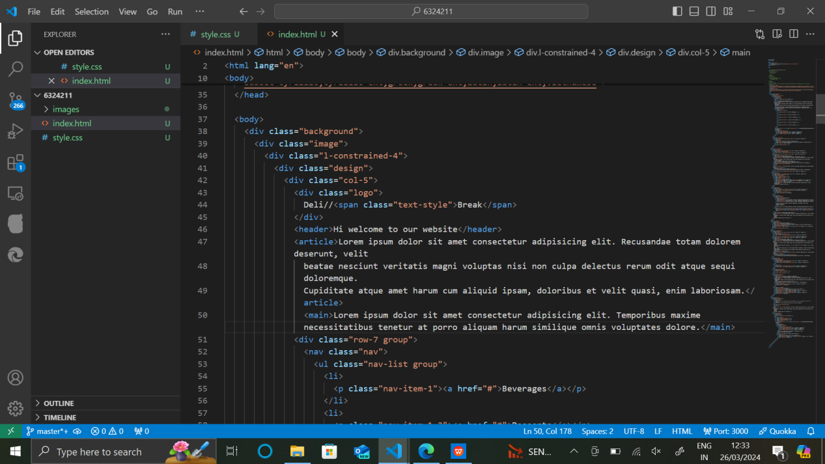

Canvas and SVG tags

